Nama : Astiany Dwi Prasinta Sari

NIM : 18090059 (5D)

**PRAKTIKUM I**

1. Code Source

Perkenalan.php -> Application/controller/Perkenalan.php

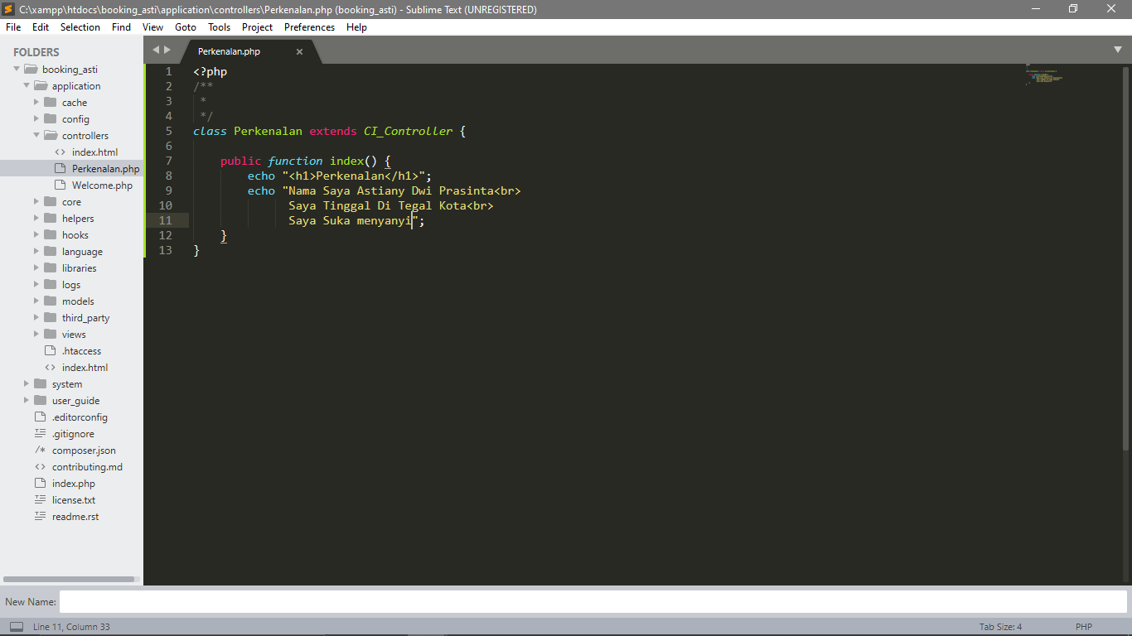

1. URL

<http://localhost/booking_asti/index.php/Perkenalan>

1. Hasil output

